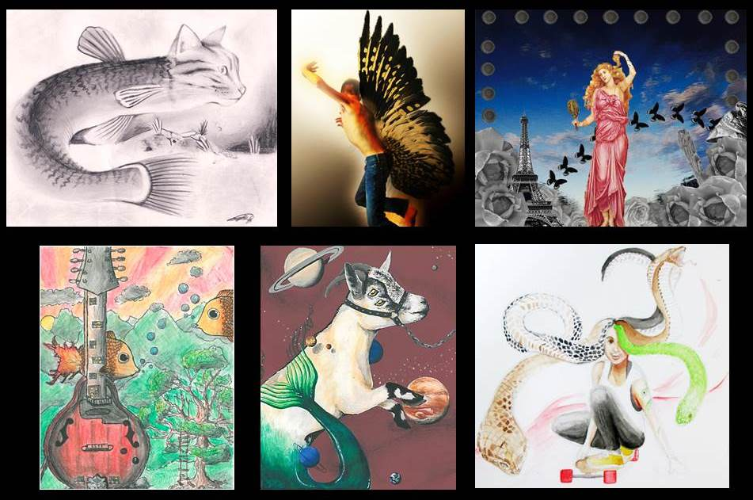

The Dali Museum Student Surrealist Art Exhibition, 2016
“Between Dream and Reality”

“I believe in the future resolution of these two states, dream & reality, which are seemingly contradictory, into a kind of absolute reality, a surreality, so to speak.” –Andre Bretón, Founder of Surrealism

About this year’s exhibit:

The Surrealists lived within two worlds: the real and the dream, the conscious and the subconscious, the rational and the fantastical. With this year’s exhibit, we invite the students to create their own “surreality” by employing one or more of the following techniques:

Dislocation: Familiar objects are placed in an odd, bizarre, humorous, or unusual setting.
Juxtaposition: Two or more unrelated images are placed side by side; creating unexpected object combinations.
Transformation/Metamorphosis: Familiar images are changed in form, appearance, nature, condition, character or function to become unusual or strange.

As in years past, the students are welcome to explore a variety of media such as drawing, collage, watercolor, acrylic, digital photography, and mixed media. To help jumpstart the creative process, works from last years’ student exhibits are available on the Dali Museum’s Flickr page: https://www.flickr.com/photos/dali_museum/sets/72157663956176075
In order to accept as many as 100 works, this exhibit must restrict the size of the works to a finished 8”x10” (no additional borders or mats). Once accepted into the show, the Dali Museum frames the works.
“Between Dream & Reality” – Hillsborough County
EXHIBITION DETAILS
- Open to middle and high school art students throughout Hillsborough County
- 8”x10” finished size. ORIGINAL WORKS ONLY. NO PHOTOCOPIES or PHOTOS OF OTHER MEDIA.
- Exhibition held Jan 11 – Mar 6, 2016 in the Dali Museum Raymond James Community Room
- Free admission extended to all student artists, their families and school personnel on night of student reception
- 18 award winners: Six (6) in Honorable Mention, six (6) in Merit & six (6) in Excellence
IMPORTANT DATES
Dec 9 | Work due to Hillsborough County Arts Office
Dec 16 | Notifications sent of selected works for exhibition
Jan 15 | Exhibit opens
 | Notify teachers of award-winning works
Feb 23 | Reception (6:30 – 8:30 PM); Awards and acknowledgements at 7pm.
Mar 6 | Exhibit ends

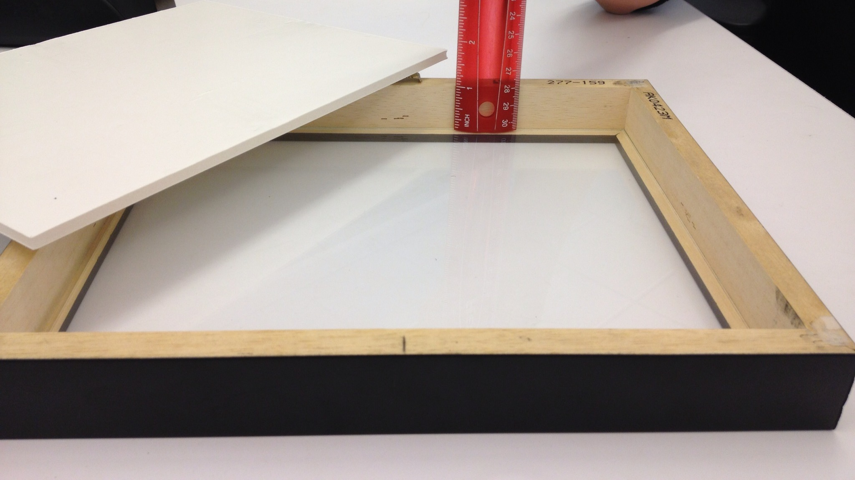
ENTRY REQUIREMENTS & SUBMISSION INSTRUCTIONS
- Up to 8 entries per teacher - one work per student
- All artwork must fit a standard 8x10 frame and must be no more than ½” thick in order to fit under glass. All work must have an 8x10 stable backing on it, with no additional mat. Finished size is 8” x 10”. Anything larger will be disqualified.
- 3-D Objects cannot be accepted for this exhibition
- NO photographic submissions of other media. Work must be original and to size.
- The Dali Museum wishes to show varied work and represent as many schools as possible, so please avoid submitting similar work by different students
- Students must submit original artwork. 8x10 scans of larger works will not be accepted.
- Framed artwork will not be accepted
- Attach the completed entry form (top and bottom) to the top back of each piece of artwork. Indicate orientation on back of piece

GUIDELINES FOR JURYING SHOW
- Originality: Artwork that exhibits an original approach to process, concept and subject matter.
- Skill/Technique: Artwork that exhibits technical competency required to successfully create a work of art in a particular medium.
- Expression: Artwork that communicates an aesthetic vision or style and visual expression of critical thinking.
- Theme: Artwork that addresses appropriately the exhibition themes of Surrealism.
Suggested Surreal Concepts and Techniques to Consider:
- Juxtaposition (Combining Multiple Unrelated Images)
- Double Images and Illusions
- Imaginative Self-Portraiture
- Personal Symbols
- Collage Technique (Surprise)
- Free-Association
Scoring Scale/Rubric:

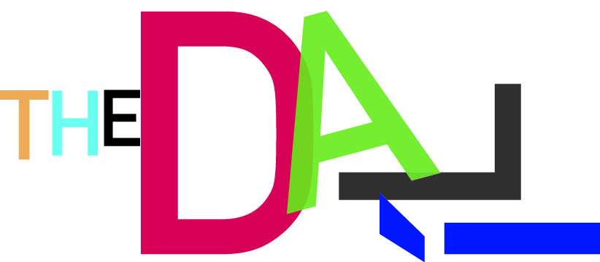  LEARNING GOAL(S) | Level 4  COMPLEX  Personal Application | Level 3  TARGET  Success for all Students | Level 2  SIMPLER  Limited Success | Level 1  PARTIAL  Minimal Success
Students will: show strong evidence of integration between the theme and the visual work. | Shows strong evidence of integration between the theme and the visual work. | Shows good evidence of integration between the theme and the visual work. | Shows little evidence of integration between the theme and the visual work. | Shows no evidence of integration between the theme and the visual work.
Students will: show strong use of innovation and inventiveness. | Shows strong use of innovation and inventiveness. | Shows good use of innovation and inventiveness. | Shows little use of innovation and inventiveness. | Shows trite or simplistic approaches.
Students will: communicate a strong personal and/or original message. | Communicates a strong personal and/or original message. | Communicates a good personal and/or original message. | Communicates limited personal vision or message. | Communicates no personal and/or original message.
Students will: show strong application of the design principles. | Shows strong application of the design principles. | Shows good application of the design principles. | Shows limited and/or inconsistent application of the design principles. | Shows no understanding of the design principles.
Students will: show excellent technical use of media to express ideas. | Shows excellent technical use of media to express ideas. | Shows good technical use of media to express ideas. | Shows inconsistent use of media and may appear unfinished.  Shows technical accomplishment but relies heavily on copyrighted photographic resources. | Shows very little or no technical competence or control of media.  Works are direct copies of copyrighted photographic resources.

The Dali Museum Education Department thanks you for your participation and expertise.

Peter Tush, Curator of Education
Sarah Fornof and Craig Petersburg, Education Department
727.623.4730 sfornof@thedali.org
727.623.4754 cpetersburg@thedali.org

ENTRY FORM: STUDENT SURREALIST ART EXHIBIT 2016
Please fill out both forms completely and attach the entire page to the top back of each artwork submitted. Please cut to size and attach and indicate correct orientation of work.
Student Name

Title of Work
Media
School, Grade
School Address & City
Teacher Full Name
Teacher Email Address
Principal Full Name

Important: Verify that the finished size is original (no photographs or other work)
and 8” x 10” or it will be disqualified.

ENTRY FORM: STUDENT SURREALIST ART EXHIBIT 2016
Please fill out both forms completely and attach the entire page to the top back of each artwork submitted. Please cut to size, attach and indicate correct orientation of work.
Student Name

Title of Work
Media
School, Grade
School Address & City
Teacher Full Name
Teacher Email Address
Principal Full Name

